SECTION 5310 ENHANCED MOBILITY OF
SENIORS AND
INDIVIDUALS WITH DISABILITIES PROGRAM

PROGRAM Reporting Manual
FOR
FTA SECTION 5310 VEHICLES
March 2019
Prepared by:
Public Transportation Programs Section
Arkansas Department of Transportation

TABLE OF CONTENTS
5310 Program Reporting Manual: Introduction 1
Minimum Vehicle Insurance Requirements 2
Performance Measurement & Monitoring 2
QPM Report: Reporting Guidance .2
Trip Purpose .3
Records Retention .6
Vehicle Release/Sale/Disposal Instructions .6
Driver’s Daily Trip Report .7
Blank Forms 9
Last Updated 3/19/19

ARKANSAS DEPARTMENT OF TRANSPORTATION
NOTICE OF NONDISCRIMINATION
The Arkansas Department of Transportation (Department) complies with all civil rights provisions of federal statutes and related authorities that prohibit discrimination in programs and activities receiving federal financial assistance. Therefore, the Department does not discriminate on the basis of race, sex, color, age, national origin, religion (not applicable as a protected group under the Federal Motor Carrier Safety Administration Title VI Program), disability, Limited English Proficient (LEP), or low-income status in the admission, access to and treatment in the Department’s programs and activities, as well as the Department’s hiring or employment practices. Complaints of alleged discrimination and inquiries regarding the Department’s nondiscrimination policies may be directed to Joanna P. McFadden, Section Head - EEO/DBE (ADA/504/Title VI Coordinator), P. O. Box 2261, Little Rock, AR 72203, (501) 569-2298, (Voice/TTY 711), or the following email address: joanna.mcfadden@ardot.gov
Free language assistance for Limited English Proficient individuals is available upon request.

This notice is available from the ADA/504/Title VI Coordinator in large print, on audiotape and in Braille.

5310 PROGRAM REPORTING MANUAL: INTRODUCTION
The Federal Transit Administration (FTA) and the Arkansas Department of Transportation (Department) use your Vehicle Maintenance Records and Quarterly Performance Measurement and Monitoring (QPM) Reports to evaluate agency performance in enhancing the mobility of seniors and individuals with disabilities.
When you receive a vehicle and throughout that vehicle’s useful life, the following documentation shall be maintained by the agency and provided to the FTA via the Department in a format and as described in this reporting manual or as may be requested in subsequent correspondence:
- Current Insurance Record
- Vehicle Maintenance Record
- Quarterly Performance Measurement and Monitoring (QPM) Report
Agencies are encouraged to keep this handbook as a resource for staff responsible for 5310 Program transportation operation, monitoring or reporting; and are advised to incorporate this handbook into systems of management and training to ensure a broad level of understanding of 5310 Program Requirements.
Up to and including the year following the sale or other disposal, note the status of released vehicles (in service/disposed of) in the Annual Application for Capital Assistance.
This manual is provided to support transportation agencies and ensure accurate program reporting
Quarterly Performance Measurement and Monitoring (QPM) Reports are required to be transmitted to the Department each quarter. Reports are compiled for 5310 Program reporting to FTA and for other purposes.
An Agency’s performance and recordkeeping are factors in evaluating future applications for Capital Assistance.
The most current program information and forms are always available on the 5310 Program webpage: http://www.ardot.gov/public_transportation/section_5310.aspx
Please use the most current forms when reporting; please use a new form each quarter and avoid copy/paste from old forms.
Program Reporting Contact:
Gloria Hagins, Public Transportation Technician, Phone: 501-569-2471
For technical and management support, contact your Section 5310 Program Manager:
Daniel Heidelberg: Phone at 501-569-4930, or E-mail at mail to: Daniel.Heidelberg@ardot.gov

MINIMUM VEHICLE INSURANCE REQUIREMENTS
- Proof of insurance naming the Department as Loss Payee is required for all 5310 Program vehicles when received and annually thereafter until the vehicle meets its useful life and is released. Since the Department is provided tort immunity in Arkansas, your policy does not need to name the Department as an Additional Insured.
- The Subrecipient shall elect a deductible amount pertaining to physical damage coverage that is not greater than $1,000; or, a lesser amount, so long as in the event of a loss, actual proceeds from the insurance coverage shall provide no less than eighty percent of the loss prior to applying a deductible.
PERFORMANCE MEASUREMENT & MONITORING
- Use the latest version of the QPM—found on the Public Transportation Website:
http://www.ardot.gov/public_transportation/section_5310.aspx
- The report is an MS Excel spreadsheet and must be completed using that software.
- Answer all of the questions on the form that apply; the form will calculate totals for you.
- Sign the form. If you have secure electronic signature software, sign the form electronically. Otherwise, simply print/sign/date/submit. A typed signature will not be accepted.
- Submit a completed QPM on the first of the month. It is considered delinquent 20 days after the quarter ends.

Reporting Period | Due Date | Delinquent After
Q1: Oct-Dec | January 1st | January 20th
Q2: Jan-March | April 1st | April 20th
Q3: April-June | July 1st | July 20th
Q4: July-Sept | October 1st | October 20th
Choose one of the following methods to submit your completed and signed QPM:
- Mail: Arkansas Department of Transportation, Public Transportation Programs, P.O. Box 2261, Little Rock, AR 72203
- Or e-mail: Gloria.Hagins@ardot.gov

QPM REPORT: REPORTING GUIDANCE
Master Applicant/Location: Enter the legal name and city of the agency that applied for the vehicle.
Site Specific Applicant/Location: If the Agency that operates the vehicle is not the Parent Agency, list the Agency/Site/Location here. If same, write same.
Contact Person: Person responsible for reporting to ARDOT
Phone #: Phone number/extension of contact person
E-mail Address: Of person reporting to ARDOT
DUNS #: Nine-digit number, Starting October 1, 2003, the Federal Office of Management and Budget (OMB), requires that a DUNS number be included in all grant applications.
FTA #: Enter vehicle’s FTA number, the four digit number on the front license plate; a separate QPM must be completed for each vehicle.
Nickname: Enter the nickname of vehicle, if applicable.
AR License Plate #: Enter the vehicle’s state issued license number.
Year: Enter the vehicle year.
Make: Chevy, Ford, Dodge, etc
Model: Check van or bus.
Federal Fiscal Reporting Quarter: Check the Federal Fiscal Calendar Quarter of this QPM.
Odometer Reading: Enter all odometer readings in whole miles.
- Starting mileage for the current quarter is always your entry in last quarter’s QPM for ending miles.
- Ending odometer will be the mileage on the last day of use for the quarter.
Air Filter: Enter the odometer reading of the most recent oil change even if it was not done in the current quarter.
Oil Filter: Enter the odometer reading and date of the most recent oil change, even if it was not done in the current quarter.
Number of Days Operated This Quarter: Enter the number of days the vehicle was utilized during the quarter. Provide an explanation for underutilization in the Incident Reporting section. Example: out of service, at shop, center closed, etc.
Miles Operated the Quarter: Total number of miles the vehicle was driven during the quarter; the spreadsheet will calculate this for you.
TRIP PURPOSE:
Transportation services provided under the 5310 Program are limited to Seniors and Individuals with Disabilities. Seniors include all individuals aged 60 years or older. Individuals with Disabilities are persons who:
- have a physical or mental impairment that substantially limits one or more major life activities;
- have a record of such an impairment; or
- are regarded as having such impairment.
Passenger Trips are calculated by the number of times a passenger enters the vehicle. Passenger Classification and Trip Purpose recorded in Driver’s Trip Reports are totaled to provide data for the QPM report. Apply your discretion when recording trip purpose. This is an example only, where shopping could be considered personal, recreational or even educational depending on the nature of your program. If a passenger goes to the doctor, store and home; three trips are provided for that passenger. If there are five passengers on each of the three legs of the trip, the total trips would be fifteen (3 trip legs X 5 riders on each). Drivers are not included in the count. Home delivered meals are not considered passengers.
Education: Education and training includes classroom as well as life skills training, wellness training, physical community interaction, etc.
Employment: Includes trips to work as well as vocational training, work sites, workshop centers, etc.
Medical: Medical related appointments, dental, physician, dialysis, rehabilitation service, etc.
Nutrition: Trips to a congregate meal Center or meal site.
Personal: Shopping, drug store, post office, family or nursing home visits, etc.
Recreational: Activities such as movies, eating out, day or overnight trips, park, mall shopping, zoo, etc.
Residence: Going home; the place your passengers return to (generally the last leg of their trip).
Agency: Employee or individual transported in the vehicle to assist a rider (aides, attendants, escorts, etc.). Count in other category only.
Administrative: Agency employees or volunteers. Trips reported when the agency utilizes the vehicle for errands, conferences, meetings, picking up or delivering goods, etc. Must be incidental to transporting Seniors and Individuals with Disabilities. Count in other category only.
Meal Delivery: Occasional meal delivery is an administrative use that must be incidental to primary passenger trips. Never displace a passenger trip for a meal delivery.
Totals: This should auto calculate. (See example below where both equal 1,162). The total number of passenger classifications equals the total number of trip purposes.
Non-Ambulatory Passengers: Of total passenger trips, how many riders used the ramp or lift? Note: This is a subset of total trips by passenger type. Report only if this is a ramp or lift equipped vehicle.
Trip Denials: Record any denial of transportation that took place during the quarter as a total and then break out any ADA denials as a separate count.
Incident Reporting: This is where you list major mechanical failures and crashes involving glass or body damage that resulted in the vehicle being out of service during the quarter. A brief description is all that is necessary.
Report Certification: Since the agency’s performance will be measured, in part, on information provided in this report, the completed QPM for each vehicle must be signed by the person authorized by the parent agency to certify on behalf of the agency that the statements included in the report are true and correct.
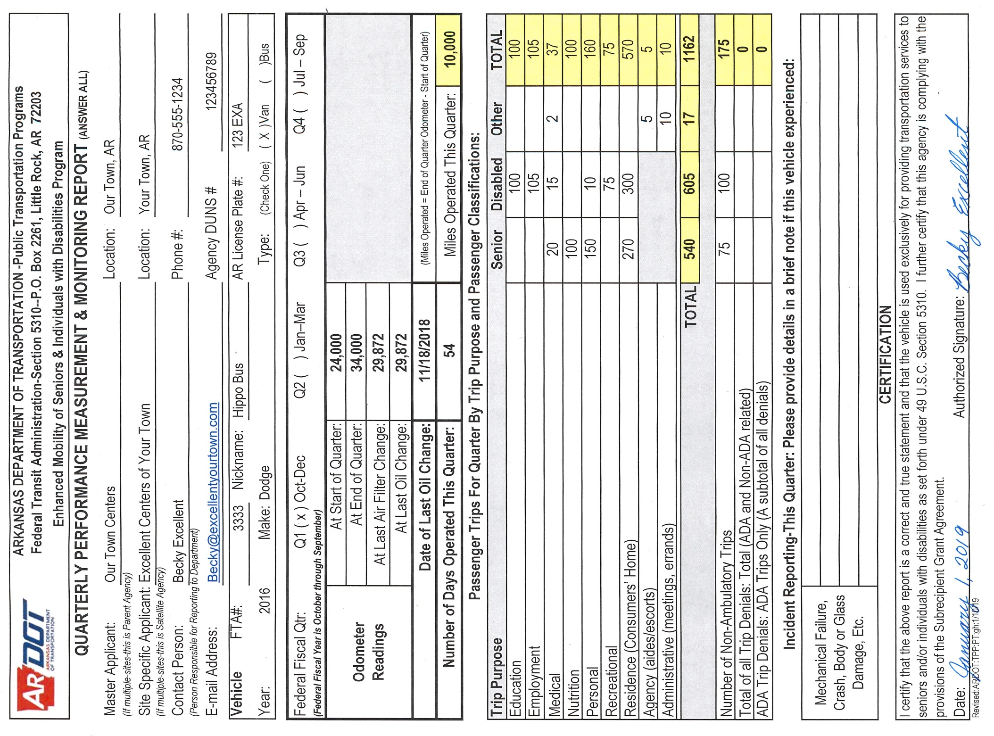
RECORDS RETENTION
All 5310 program participants must follow federal standards as to records retention in documenting vehicle operation, maintenance and repair. After a 5310 vehicle is released from reporting requirements, records relating to that vehicle on the day of release shall be retained for no less than 48 months.
VEHICLE RELEASE/SALE/DISPOSAL INSTRUCTIONS
Only the Department will determine if/when a subrecipient’s vehicle has met its useful life. Vehicles meeting the minimum service years and/or minimum miles (Vans= 4 years and/or 100,000 miles, Buses = 5 years and/or 150,000 miles. ) are considered for release and are released on a case-by-case basis, based on the ending odometer reading from the most recent QPM Report.
To ensure compliance with Program limitations, and avoid potential penalties, the process specified by the Department must be followed in the sale and disposal of Section 5310 program vehicle. If the Department releases a vehicle, a Notice of Release along with the Vehicle Title, Lien Release and Inventory Control Reporting Form will be sent to the Subrecipient Agency. Once released, capital inventory items may be retained, sold or otherwise disposed of provided that the agency complies with FTA/Department rules limiting sale and disposition.
The status of released vehicles (sold/retained) is disclosed in the annual application for Capital Assistance.
When a vehicle is released ensure that the following actions are taken.
- Please remove the Federal Transit Administration (FTA) license plate from the vehicle(s).
- Take the title(s) to your local revenue office to have the Department removed as the lien holder.
Upon a decision to dispose of the vehicle(s), the following actions are required by both State and Federal Law. Failure to do so is a violation of Arkansas State Code § 19-11-242; Code of Federal Regulations Title 49 Part 18 Subpart C Subsection 32.e,f (49 CFR 18.C.32.e,f) and CFR Title 49 Part 19 Subpart C Subsection 32 (49 CFR 19.C.32).
- The State requires sales by public auction, competitive sealed bidding or other appropriate method.
- Public notice of at least five (5) days prior to sale is required in either a newspaper of general circulation in the area where the vehicles are located, as a post on your website, or on your social media account(s).
- No member of the Board or employee of your corporation shall be entitled to purchase these vehicles.
- When proceeds exceed $5,000 per vehicle, the federal share (80%) of the proceeds must be returned to the Department according to FTA guidelines (unless prior approval to use proceeds to offset the cost of a “like-kind” vehicle is given by the Department).
- Upon disposal of these vehicles, please submit an enclosed Property Inventory Control Form listing the amount of the sale for each vehicle. Also include a copy of the newspaper advertisement, or a screen shot of the notice from your website or social media account(s).

DRIVER’S DAILY TRIP REPORT
The Daily Trip Report form must maintain for each vehicle operated under the 5310 program; recording each trip by Passenger Classification and Trip Purpose.
A unique record must be made for each day of vehicle operation, recording:
- The beginning and ending odometer reading for each day of operation-in whole miles.
- The number of passengers transported for each day of operation by Passenger Classification.
- Each passenger’s destination, by trip purpose.
- The Passenger Classification of each person entering the vehicle (Senior, Disabled or Other).
- The desired destination of each passenger in the column titled Trip Purposes.
Follow this process at all times the vehicle is in service. Each time you pick-up a passenger you will enter a Passenger Classification and trip purpose as a new entry-even if you dropped them off and are back to pick them up.
NOTES:
- Report Non-Ambulatory Trips only if the vehicle is equipped with a lift or ramp. This count includes anyone who enters the vehicle using the lift or ramp and may or may not involve a mobility device.
- If a person is both a Senior and Disabled the driver should use their discretion when recording the person’s Passenger Classification. At no time should a passenger be classified in more than one column.
- Record each leg of the trip to reflect a trip to the next destination.
- Since each leg of the trip allows for a new Trip Purpose, there is never more than one purpose for a passenger’s trip. If a passenger is doing several things at one location, pick one for that leg of the trip.
- If an employee or volunteer needs to assist a passenger for any reason, the employee’s trip is recorded under Agency and in the Other category. If an Attendant (Caretaker) needs to accompany a passenger to an appointment, record their trip in the other category and under the same trip purpose as the passenger.
- Home-delivered meals are not counted as passengers.

BLANK FORMS
Forms on the following pages are provided as examples to improve the value of this handbook in staff training and program management. The most current versions of 5310 Program forms are always available on the Department website or by contacting the Department.

Please source all 5310 Program forms for reporting from our website, here:
http://www.ardot.gov/public_transportation/section_5310.aspx
For more information, contact your Section 5310 Program Manager:
Daniel Heidelberg: Phone at 501-569-4930, or E-mail at Daniel.Heidelberg@ardot.gov

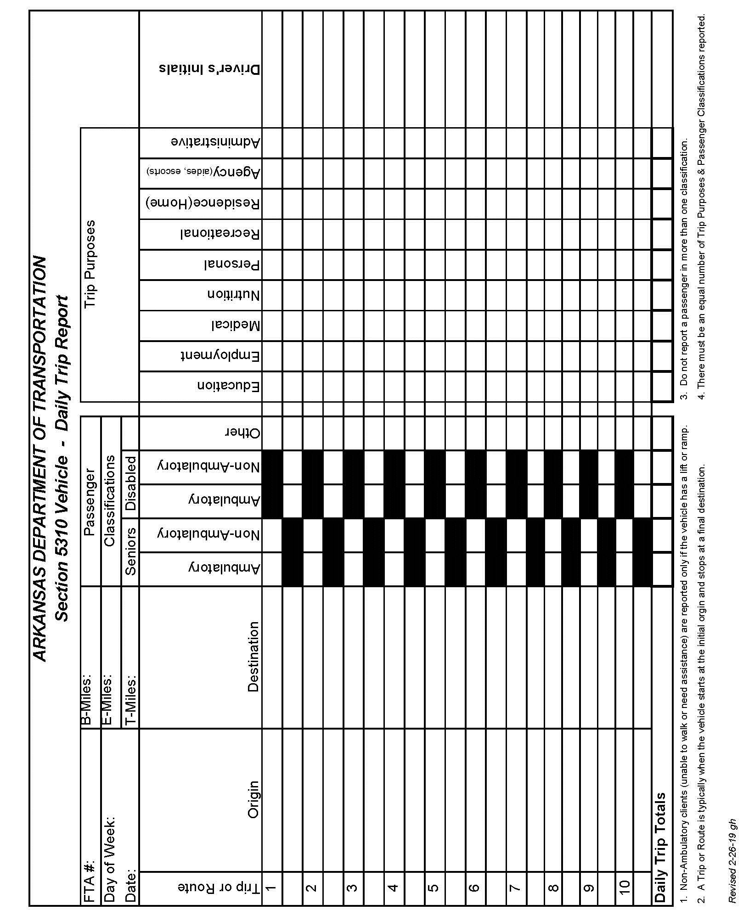
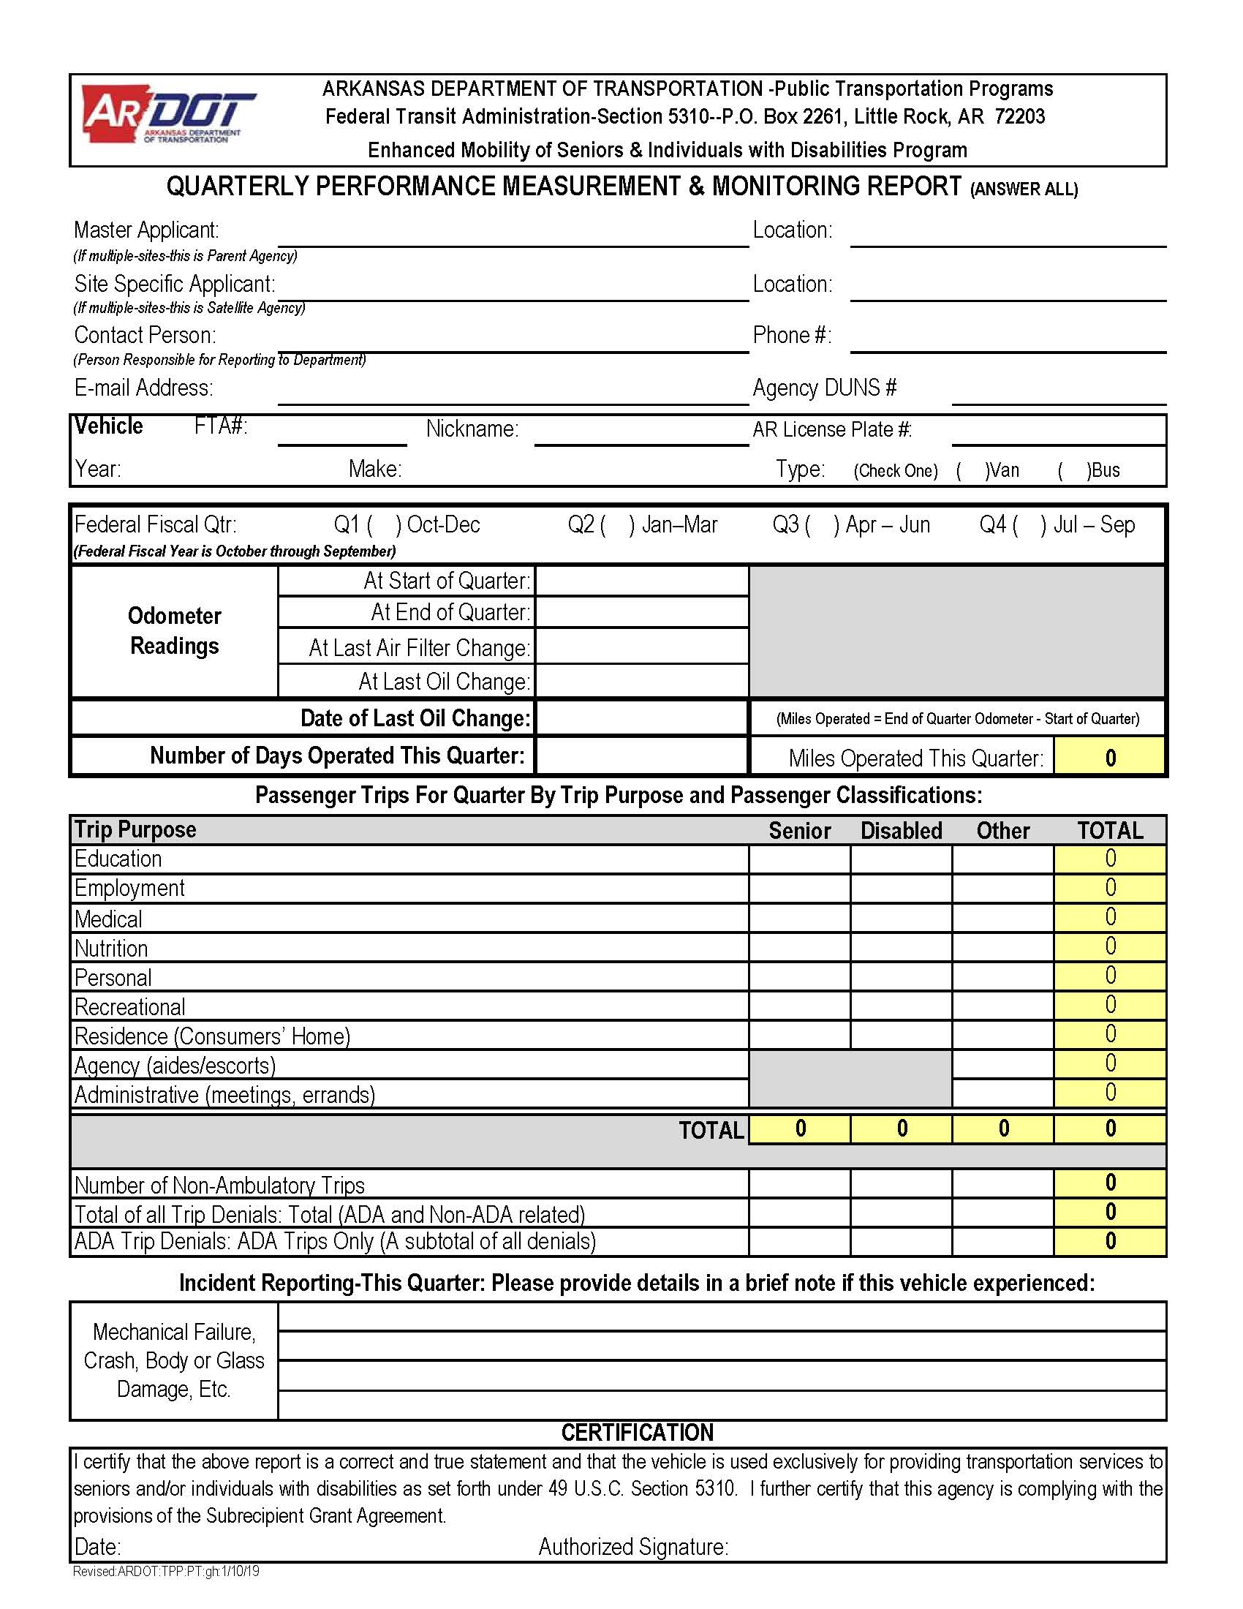

DO NOT COPY
